**Level Design: The level of Newbie CS415 Game Designer.**

Lore: The Creator, who started Assignment 2 only 3 days before the deadline, was pulled into his unfinished game after staying up to 3 am. Now he must collect all of the key of knowledge to finish the level to leave this place.

The level map:

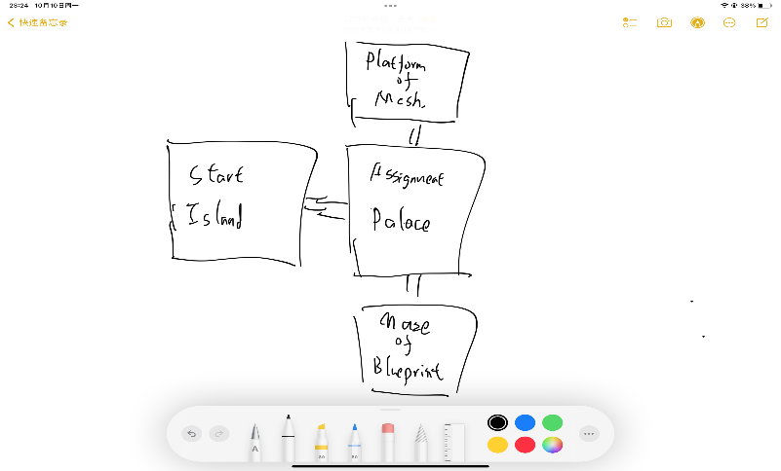

Design Idea: The idea of design the level is to separate 3 kinds of enemy in different island, with one collectable item on each island. The idea of using island as each different platform is to use the existing map resources provided by the learning kit.

Gameplay Analysis: The player will start at the edge of start island, and then he will be told he should collect 4 keys of knowledge (collectable), and will be told what is the key and what is the health pack. Then he/she will go to the Assignment Palace (Central Island), where a Pursurer Enemy will be present. After that, the player can choose to go to either platform of mesh or the maze of blueprint. The mortar enemy is on the platform of mesh, so floating platform is provided on the island for the player to avoid the bullet. The gatekeeper, my custom enemy, is presented in the maze of blueprint. It can only be distracted by pressing a button in the maze and without being seen by the enemy, otherwise it will return to the gate and prevent you from accessing what behind them.